Exp No:2 Upload and Analyse the data set given in csv format and perform data
preprocessing and visualization.
AIM:
Upload and Analyse the data set given in csv format and perform data
preprocessing and visualization.

Description: Use sample data set sales-data.csv.
CODE:
import pandas as pd
import numpy as np
import matplotlib.pyplot as plt
import seaborn as sns
file_path = 'sales-data-new.csv'
df = pd.read_csv(file_path)
print(df.head())
print(df.isnull().sum())
df['Sales'] = df['Sales'].fillna(df['Sales'].mean())
df.dropna(subset=['Product', 'Quantity', 'Region'], inplace=True)
print(df.describe())
product_summary = df.groupby('Product').agg({
'Sales': 'sum',
'Quantity': 'sum'
}).reset_index()
print(product_summary)
plt.figure(figsize=(10, 6))
plt.bar(product_summary['Product'], product_summary['Sales'])
plt.xlabel('Product')
plt.ylabel('Total Sales')
plt.title('Total Sales by Product')
plt.show()

df['Date'] = pd.to_datetime(df['Date'], dayfirst=True)

sales_over_time = df.groupby('Date').agg({
'Sales': 'sum'
}).reset_index()

plt.figure(figsize=(10, 6))
plt.plot(sales_over_time['Date'], sales_over_time['Sales'])
plt.xlabel('Date')
plt.ylabel('Total Sales')
plt.title('Sales Over Time')
plt.xticks(rotation=45)
plt.show()
pivot_table = df.pivot_table(
values='Sales',
index='Region',
columns='Product',
aggfunc='sum',
fill_value=0
)

print(pivot_table)

# Correlation matrix
correlation_matrix = df[['Sales', 'Quantity']].corr()

print(correlation_matrix)

plt.figure(figsize=(8, 6))
sns.heatmap(correlation_matrix, annot=True, cmap='coolwarm')
plt.title('Correlation Matrix')
plt.show()
OUTPUT:
Date Product Sales Quantity Region
0 01-01-2023 Product A_New 223 5 North_New
1 02-01-2023 Product B_New 173 4 South_New
2 03-01-2023 Product A_New 243 6 North_New
3 04-01-2023 Product C_New 323 7 East_New
4 05-01-2023 Product B_New 203 5 West_New
Date 0
Product 0
Sales 0
Quantity 0
Region 0
dtype: int64
Sales Quantity
count 16.000000 16.000000
mean 260.500000 6.375000
std 64.031242 1.746425
min 173.000000 4.000000
25% 210.500000 5.000000
50% 248.000000 6.500000
75% 325.500000 8.000000
max 363.000000 9.000000
Product Sales Quantity
0 Product A_New 1488 39
1 Product B_New 965 22
2 Product C_New 1715 41
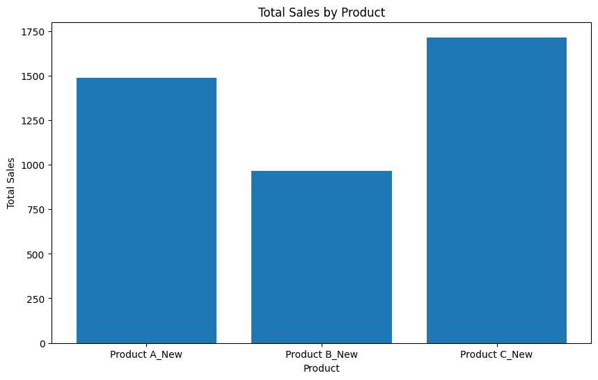
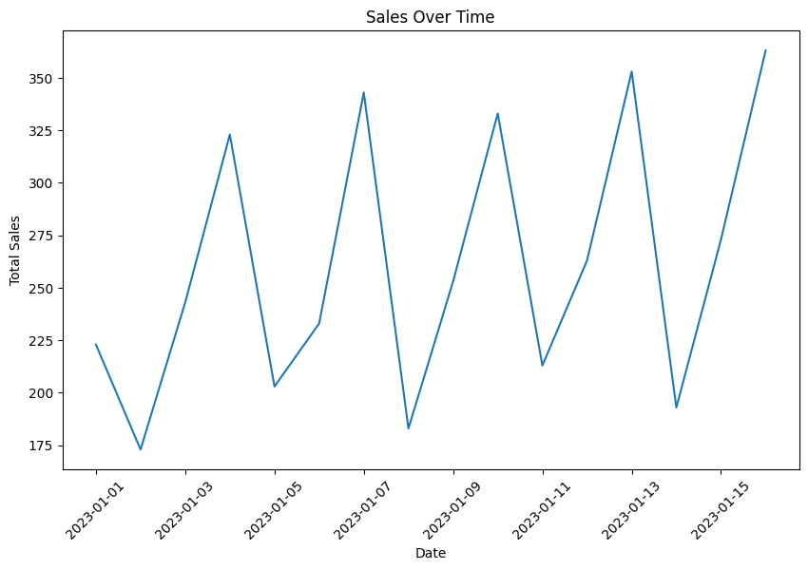
Product Product A_New Product B_New Product C_New
Region
East_New 0 0 1715
North_New 1488 0 0
South_New 0 549 0
West_New 0 416 0
Sales Quantity
Sales 1.000000 0.944922
Quantity 0.944922 1.000000
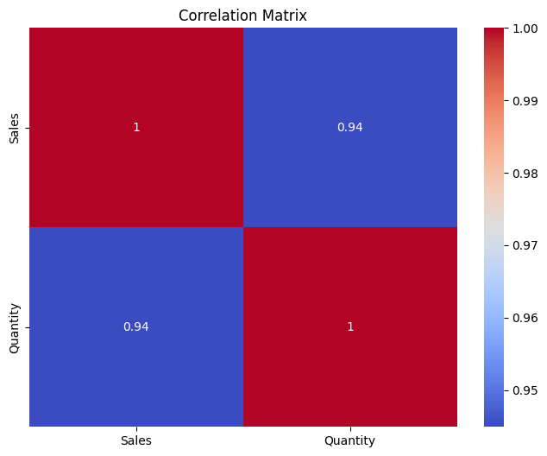

RESULT:
The sales data was successfully analaysed and chart showed product-wise sales,sales trend,and the correlation between sales and quantity.

